Yifeng Liao & Talal Al-Otaibi
ME 348F: Advanced Mechatronics 2
Professor Zhou
September 25, 2022

Lab 2 Report
Lab Experiment 2.1:

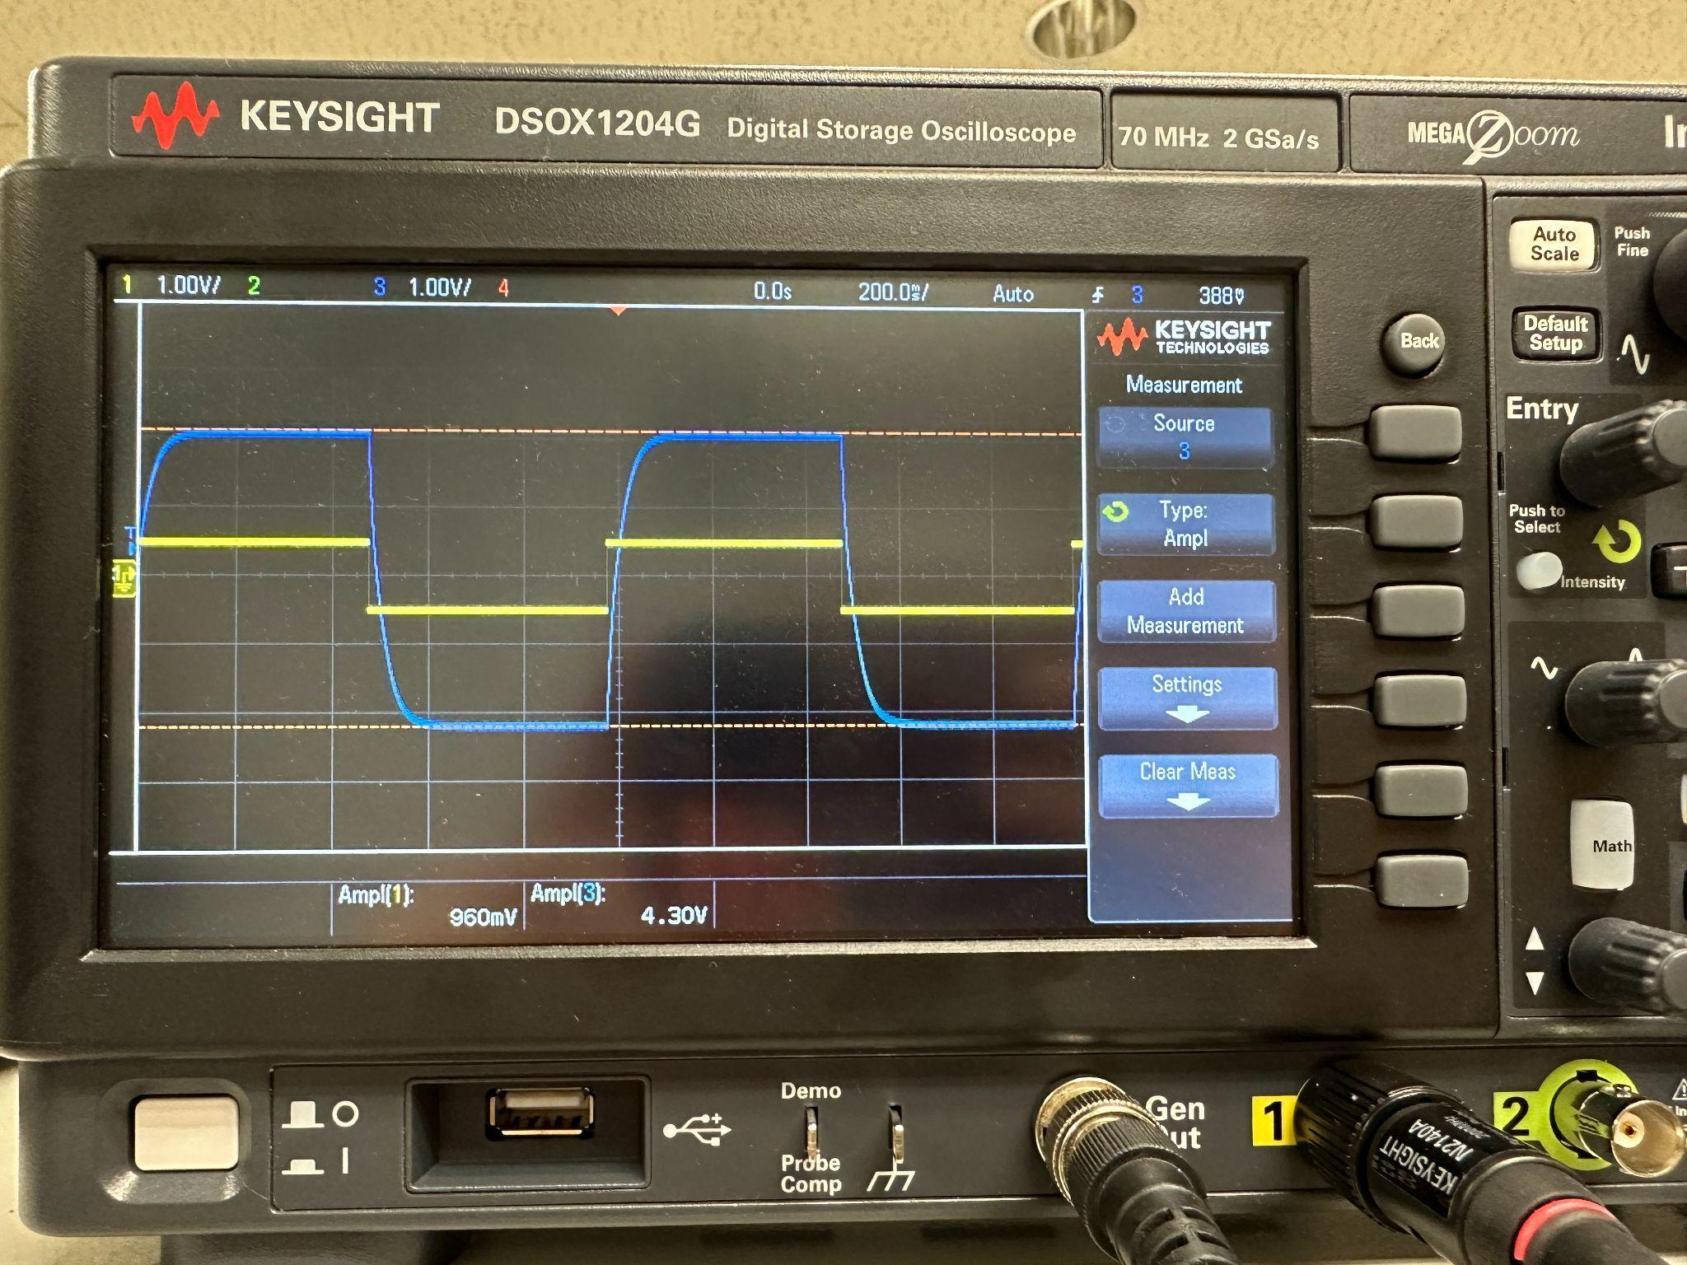
Figure 1: Step Response of the Voltage Controlled Power Amplifier

For this part of the lab, we input a square wave with amplitude of 1V peak-to-peak and frequency of 1 hz. The obtained response from the amplifier matches our expectation because at a low frequency, the ratio of V_s / V_r should be about 4.44, which is proven in the figure.

Lab Experiment 2.2:
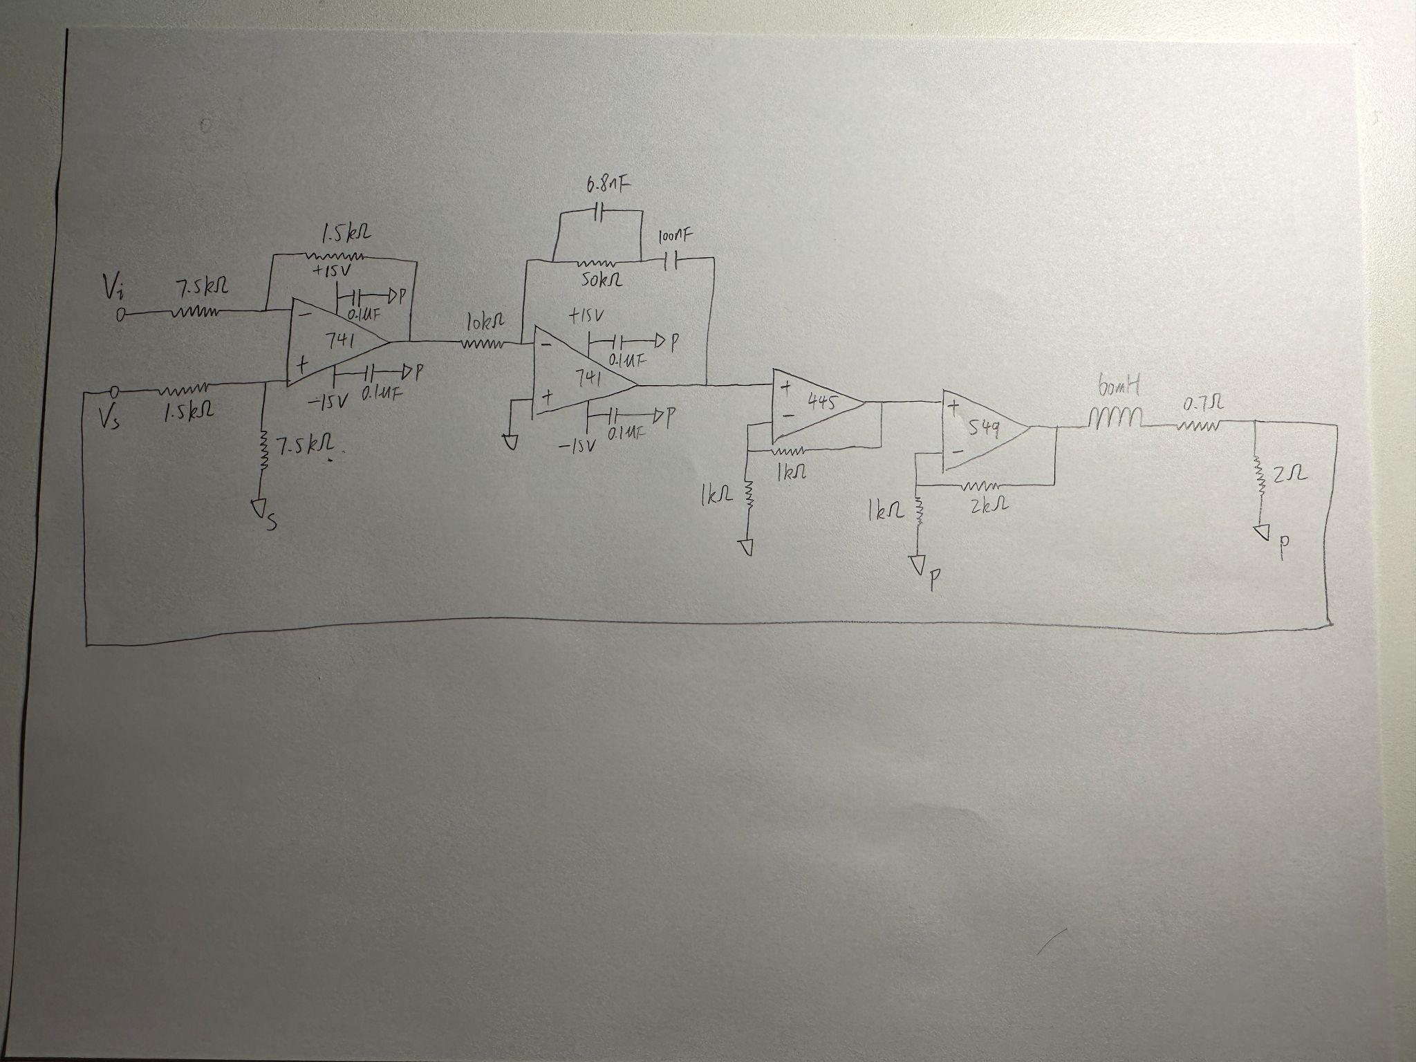
Figure 2: circuit diagram of the final implementation of the current controller

Lab Experiment 2.3:
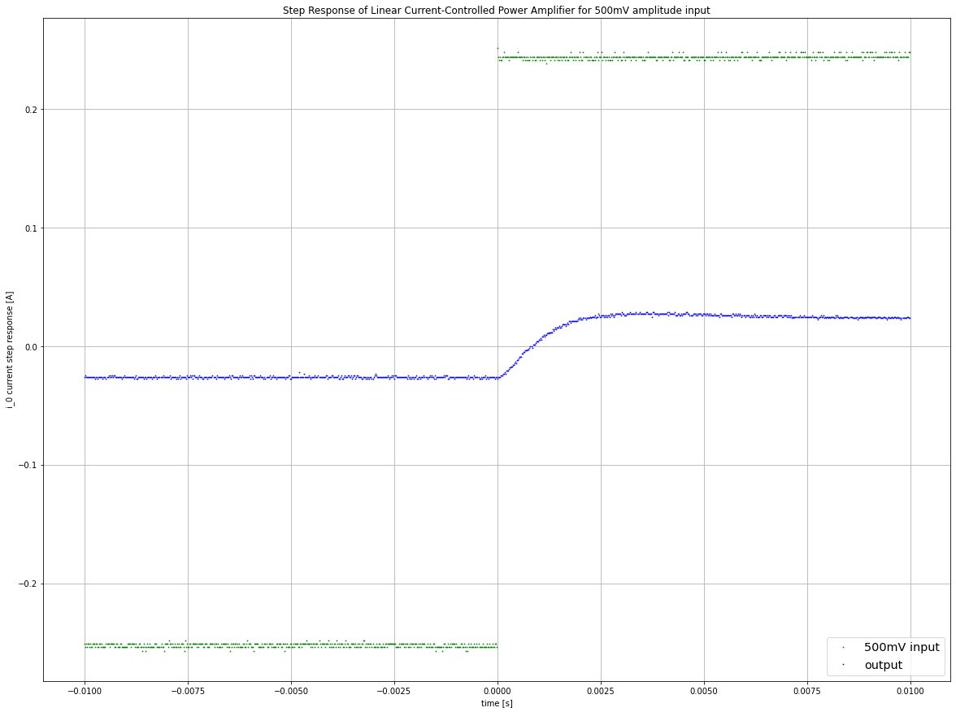
Figure 3: Step Response of Linear Controlled Power Amplifier for 500mV peak-to-peak amplitude input (i_o vs. V_i)
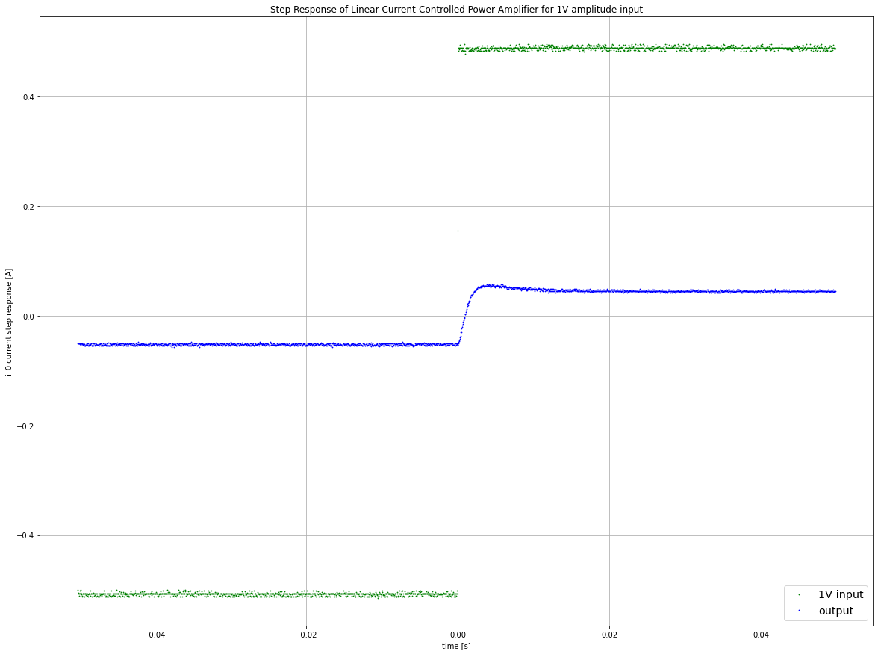
Figure 4: Step Response of Linear Controlled Power Amplifier for 1V peak-to-peak amplitude input (i_o vs. V_i)
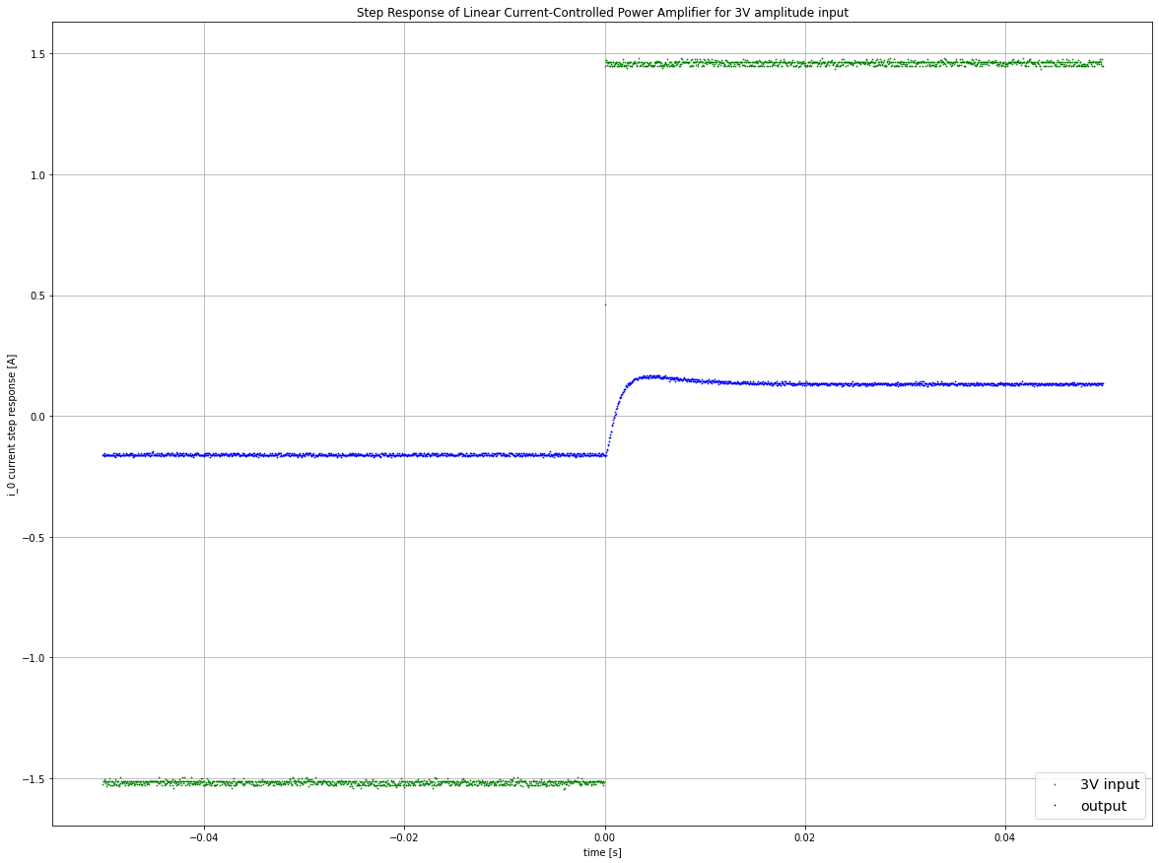
Figure 5: Step Response of Linear Controlled Power Amplifier for 3V peak-to-peak amplitude input (i_o vs. V_i)
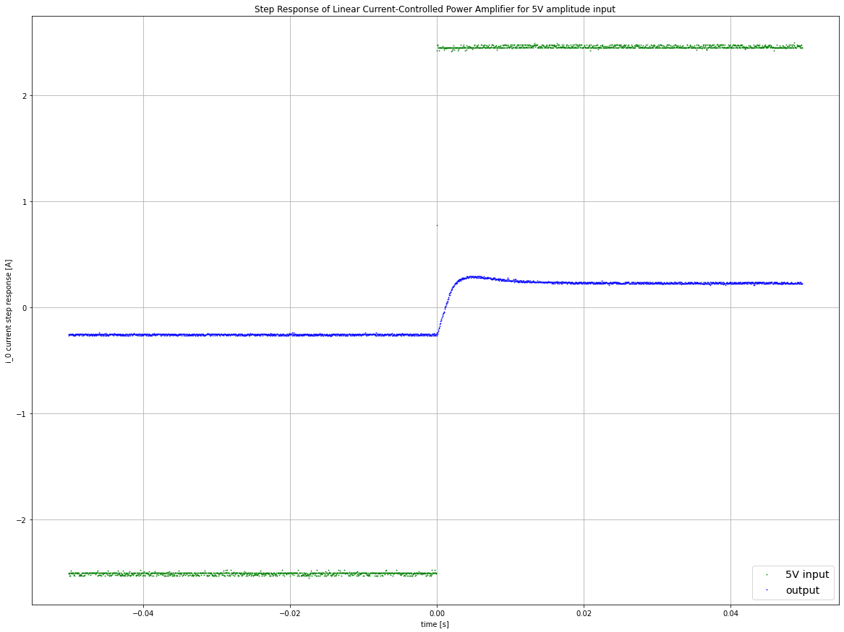
Figure 6: Step Response of Linear Controlled Power Amplifier for 5V peak-to-peak amplitude input (i_o vs. V_i)

By comparing the step response of our system among different input amplitudes, we found that the rise times and overshoots generally increase when the amplitude increases. The rise times of the responses with amplitudes of 500 mV, 1V, 3V, and 5V are 0.00198 seconds, 0.00215 seconds, 0.00245 seconds, and 0.0026 seconds, respectively. This is because under large step input, the slew rate of the operational amplifier limit dominates (specifically the second 741 op amp in the current controller), thus increasing the rise time of the response. Overall, a higher voltage differential given a constant slew rate limit increases the system response rise time. It is important to note that deductions and analyses were made on discretized data points that were noisy, hindering the reliability of any exact values. Therefore, all the values are estimates and it is safe to assume variances for every calculated metric.

When analyzing figure 3, the small signal step-response, the result matches our expectation. The close-loop gain of our system is about 10.6, while our theoretical value is about 10. Using the following equations and our experimental measurements, the experimental damping ratio of our system is 0.645, which implies a phase margin of 64.5 degrees. This value is very close to our expected phase margin of 62.5 degrees. The calculated crossover frequency of our system was 909 rad/s, while our theoretical crossover frequency is 1000 rad/s.

Appendix:
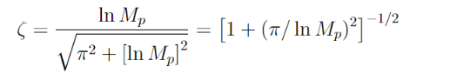 (1)

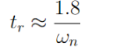 (2)
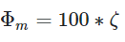 (3)

